Potentials

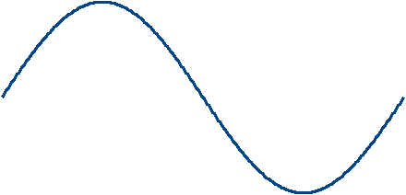
V (x)
0
-E
x
Sin (x)
Standing Wave
Potential Energy
Particle in a Box
Probability
W (x, t)
(x, p)
a
-a

Introduction

In order to understand potentials (V) we need to return to the particle in a box, the standing wave, the wave on a rope, and particle collisions, and electron orbitals. Potentials (V) describe how much energy (E) is needed to change the state of a particle.
This is described mathematically in physics through graphs of potential energy (PE) or V (x).
The reason why we study these models, is that each model represents a situation where the particles are interacting in our system, and each model offers a different view on how the potential energy V (x) affects the system and particles.
For the ball in the tube, the walls of the tube represent a potential barrier that the ball can break through, if it has enough energy to do so. Shake the tube hard enough, and the ball can puncture a paper barrier in the tube.
If the particle and the barrier are made of the same material, the particle can travel through the barrier (tunnel) and continue traveling. This is demonstrated with a horizontal string attached to a vertical string. While the vertical string should act as a wall, the wave can travel through it (aka tunnel), and continue traveling down the 2nd string, while reflecting back.
Then there are cases where the barriers don't appear to be present, yet, the potential of a particle can change another particles trajectory. We see this happen when a photon interacts with an electron.

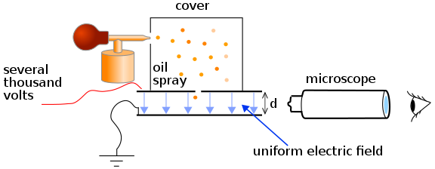

The photo electric affect is a great example to study when reviewing potentials. Another great experiment is the Millikan Oil Drop experiment. Both experiments use voltage potential (V) to determine the mass of the electron. So, let's walk through the components of the photo electric affect to better understand how potential plays a role.

Photo Electric Affect
A
V
Rheostat
Battery
Voltage
Battery
Free
Electron
Light
Anode
Cathode
(+)
( - )

The photo electric affect is a great example to study when reviewing potentials (V). This experiments can use the voltage potential (V) to determine the mass of the electron (me), by measuring the amount of time (Δt) it takes for the electron to move from the anode to the cathode (Δd) . So, let's walk through the components of the photo electric affect to better understand how potential (V) plays a role.

Not shown, is the vacuum enclosure glass tube that prevents electrons from losing kinetic energy (KE) they otherwise would by colliding with air molecules in the void between anode and cathode capacitor. The electric field (EF) flows through the void, when voltage (V) is applied, and interacts with the electrons (e) via their charge (q).

When a metal surface on the anode is exposed to a monochromatic electromagnetic wave (λ), the incident radiation is absorbed and an electron is emitted. Initially, the potential difference (ΔV) between the anode and cathode allows the electron to fly across the gap, and be registered as current by the ammeter.

The potential difference (ΔV) between the anode and cathode can be increased, decreased, and reversed to see how the electron responds to the change in potential difference (ΔV).

Electrons move towards the cathode, because it is kept at a lower potential (V) with respect to the anode. When the anode is connected to the negative terminal of a battery and exposed to light (λ), a current is registered in this circuit.

When the target material is not exposed to light (λ), no current is registered in this circuit because no electrons are emitted for the cathode to collect.

If the potential difference (ΔV) between the electrodes is reversed so that the anode now connects with the positive terminal of a battery, and the voltage is slowly increased the current gradually dies out and eventually stops flowing completely at some voltage. The potential difference (ΔV) at which the current stops flowing is called the stopping potential.

It's this stopping potential that tells us how much mass the electron has.

Now, this experiment wouldn't be complete, if we didn't tests different metal anodes and see how they react to different wave lengths (λ) to see how they respond. Recall, we can test each metal to see which wave lengths (λ) it emits and absorbs using using spectral analysis.

Recall, Einstein was concerned with the intensity (I) of the light (λ) applied to the metal. We are not concerned with that aspect of the experiment for this discussion, as we are focusing on the kinetic energy (KE) that an electron has as it passes through the void between the anode and cathode.

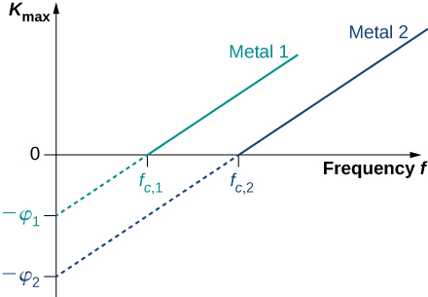

Now that we know how to calculate the kinetic energy (KE) of the electron (e) when it is emitted using the photo electric effect, we can adjust the voltage (V) to slow the electron (e) down such that we can calculate it's velocity (v) in the give distance (d) between the time the electron is emitted by the light pulse (λ) and the time (t) that the ammeter detects it.

Let's begin with this thought experiment of using the photo electric effect to find the mass of the electron (me). First, the wave length of light used (λ) must be transformed into the frequency of light, [1], for most of the calculations we will perform. Next, the energy that a photon has (Ef) is equal to Plank's constant (h) and the frequency (f), [2].

The kinetic energy (KE) that an electron has is equal to the energy of the photon (Ef) minus the energy needed to emit the electron (O), [3 - 4]. The stopping voltage (Vs) is equal to the the energy needed to emit the electron (O), [5].

With this information we can find the cut off frequency (fc) we can use to test different frequencies (f) of light (λ). This will allow us to adjust the voltage (V) in the capacitor to determine velocity (v) of the electron (e) statistically as it travels the distance between the anode and cathode, [11].

Since we can pit the voltage potential (V) against the kinetic energy (KE) to stop the electron from moving, we can use this to determine the electron's speed at any given time, by setting the voltage (V) to different values measuring how long (t) the electron (e) takes to move from the anode to the cathode, [12].

Since, the distance (d) is fixed and we can measure the time (t), we can calculate the velocity (v), and since the kinetic energy (KE) is the maximum kinetic energy (KE-max) minus the voltage (V), we can have a velocity in the range from a velocity of zero to KE-max. By using statics, we can use these data points to calculate the mass of the electron (me) using the basic kinetic energy equation [13], which is (1/2 m v^2). By solving for mass, and substituting the velocity with the distance divided by time, we have can derive a rough approximation of the mass of the electron statistically, [14 - 16]. Which, statistically comes close to 9.109e-31 kg, [17].

For some light reading, you might want to review the Millikan Oil Experiment which provided the electric charge (q) of the electron (e), and JJ Thompson's cathode ray tube deflection experiment where he used the electric field and magnetic field to find a relationship between the electron and it's mass (e / m).

This experiment allows you to visually see how a potential (V) is used to determine what will happen with a particle, in this case an electron (e). And, since we are relying on the time (t) needed for an electron (e) to move between the anode to the cathode, our timer is based on how fast the detector sees a change in amperage. Again, we are counting the microseconds between when a photon (λ) is emitted from a light source and when an electron (e) is detected by the ammeter. As you can see, there are many points of uncertainty (dx)'s.

Potential Wells
Potential wells are described in classical physics as a ball raised above a table. The ball, can stay in the air, held by a hand, but will fall when released. The energy the ball feels that causes it to accelerate is gravity.
We can describe this example mathematically through a graph of potential energy (PE) over time (t). Showing that when the ball is released in the air, the potential energy (PE) from gravity (m g h) is high. As the ball falls to the ground, it's potential energy (PE) falls off as it reaches terminal velocity (v). And, when the ball hits the ground, it's potential energy (PE) is zero. The ball can not travel any further.
Now, consider a free particle moving along, minding it's own business, when suddenly it encounters a potential V (x) that rises from (V0) to some value (V1). This can be viewed using three figures:

- A particle hitting a wall.

V1
V0
0
-a
a
- A graph of potential (V) over distance (x).

- An electron jumping up and down orbitals, as the photon is absorbed or emitted.

Now, let's consider the energy (E) that a free particle has, [1 - 2]. As long as the particle is moving in a potential energy free zone ( V(x) = 0 ), this obeys Newtons law that an object in motion stays in motion, and an object at rest remains at rest, unless acted upon by an external force.
In quantum mechanics the physical state is governed by the Schrödinger equation, [3], and generally there is no reason that the wave function must be exactly zero in regions where energy (E) is less than the potential energy V (x). This means that there is usually a finite probability to find a particle in the classically forbidden regions, and this fact gives rise to some remarkable phenomena which are inconceivable at the classical level. Nevertheless, the wave function (w) does behave quite differently in the classically allowed and the classically forbidden regions, as one might expect, since classical behavior is an approximation to quantum mechanics, and should become exact as h-bar approaches 0 in the limit.
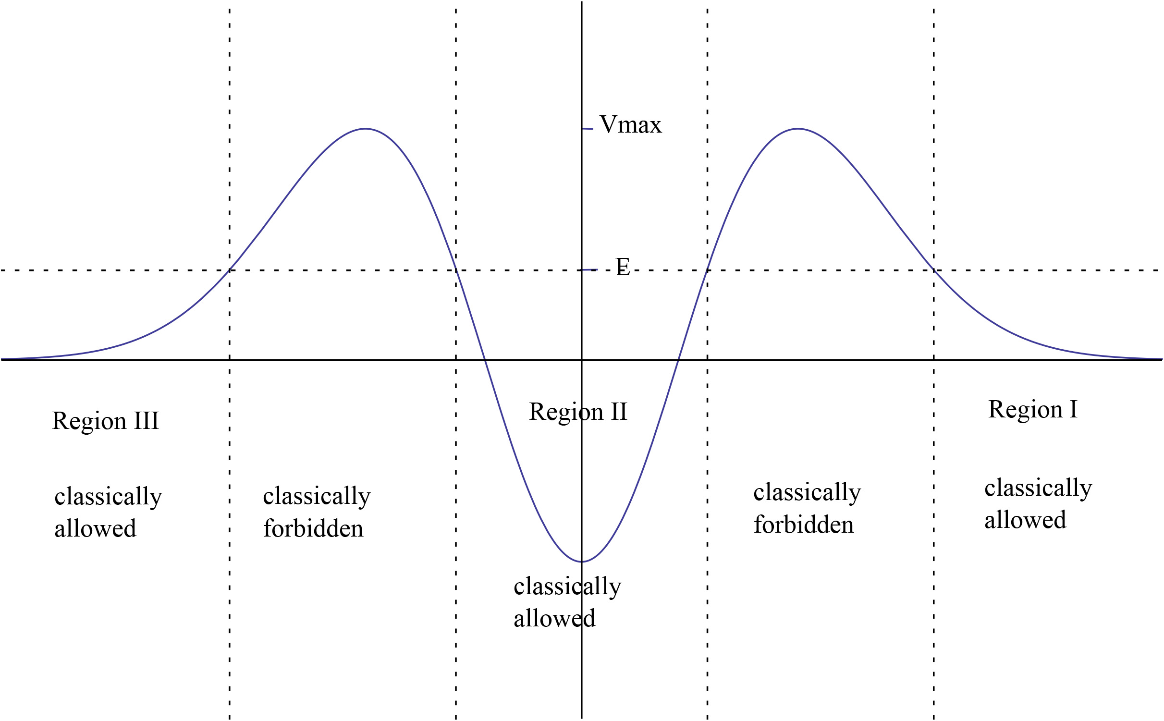
Presented here is a graph of the particles kinetic energy (KE) vs potential energy (PE) and the probability of finding it in different regions of space (x). Where the particles kinetic energy (KE) is less than the potential energy (PE) of the barrier it's approaching, the particle would not be found.

Regions
V0
0
-a
a
V1
Using the particle in a box, there are 3 regions to consider.
- Region 1 .. x < -a
- Region 2 .. x = [-a .. a]
- Region 3 .. x > a

These regions also define where the particle can and cannot be, and what the potential (v) is in each region. For example, the particle in a box, the particle cannot be found in regions 1 or 3, because the particle is trapped inside the box, region 2.
These regions also dictate what the wave function (w) looks like for each region, as it is composed of the sum of wave functions (w1, w2, and w3), [4], which are broken down further into energy eigen states ( O1 [n], O2 [n], and O3 [n] ), [5 - 7]. Each eigen state O (x), will have it's own equation [8] which describes the wave as it travels through it's region.
If certain parts of the energy eigen state O (x) would cause the wave equation (w) to explode, there constant coefficients (A - G) can be set to zero, [5 - 7].
Each wave function (w), must have a node at the boundary between the regions, [9 - 11]
Because the wave function (w1) in region 1 must match the wave function (w2) in region 2, the original equation, [12 and 14], and second derivatives must also match, [13 and 15].
We will see with different examples that particles not contained in a box, may be considered free particles. Particles that smash into other particles, create scattering patterns, where we want to know what the wave function what the particle is in at each state of scattering.
Most of the time spent, mathematically, will be spent finding the relationships between the various constant coefficients (A - G), which will later be used to determine the intensity of the Initial (I), Reflected (R) and Transmitted (T) particles or photons, [16 - 17].

Classically Allowed Regions
Classically allowed regions are regions where the particle would be found through classical physics experiments. This region is differentiated as sub atomic particles can also be found in classically forbidden regions.

Classically Forbidden Regions
Classically forbidden regions are regions where the particle would not normally be found through classical physics experiments. However, the particles wave function (w) may allow the particle to tunnel through a potential barrier (V), and appear on the other side of it.

Binding Potentials
What happens when energy (E) goes negative. This concept is studies when a free particle finds it's self being trapped by a nucleus. The nucleus takes energy away fro the particle to trap it in one of its orbitals. In order for the particle to become free, energy must be added to the particle.
This is similar to launch a rocket. Energy must be used to make the object leaving earth and sustain an orbit around the earth.

Non Binding Potentials

Forbidden domains

Forbidden regions

Quantum corral

Zero Potential - Free Particle

When the potential energy V(x) is zero within a region of space, it signifies that the particle experiences no additional force or influence from its surroundings within that region.
This particle is known as a free particle.
There are two examples of this, the first is an atom like oxygen bounces around inside a box. The other is when an electron flies over a copper atom on its way to power your house.

Step Potentials
V1
V0
0
-a
a
I
R
T
I
II
III
There are 5 different step potentials (V) to review. While they will be listed here, they will be discussed elsewhere. In addition, these potentials (V) can also be examined in all 3 dimensions .. 1D, 2D, and 3D.
If we look at a particle traveling from left to right, there are two regions defined by (x < 0 and x > 0). Let's use roman numerals to identify the left region I and the right region II.

V1
V0
0
-a
a
I
R
T

V1
V0
0
-a
a

V1
V0
0
-a
a
I
R
T
-V1
V0
0
-a
a

Particle in a Box
V0
0
-a
a
V1

In quantum mechanics, the particle in a box model (also known as the infinite potential well or the infinite square well) describes the movement of a free particle in a small space surrounded by impenetrable barriers. The model is mainly used as a hypothetical example to illustrate the differences between classical and quantum systems. In classical systems, for example, a particle trapped inside a large box can move at any speed within the box and it is no more likely to be found at one position than another. However, when the well becomes very narrow (on the scale of a few nanometers), quantum effects become important. The particle may only occupy certain positive energy levels. Likewise, it can never have zero energy, meaning that the particle can never "sit still". Additionally, it is more likely to be found at certain positions than at others, depending on its energy level. The particle may never be detected at certain positions, known as spatial nodes.
The particle in a box model is one of the very few problems in quantum mechanics that can be solved analytically, without approximations. Due to its simplicity, the model allows insight into quantum effects without the need for complicated mathematics. It serves as a simple illustration of how energy quantizations (energy levels), which are found in more complicated quantum systems such as atoms and molecules, come about. It is one of the first quantum mechanics problems taught in undergraduate physics courses, and it is commonly used as an approximation for more complicated quantum systems.
The simplest form of the particle in a box model considers a one-dimensional system. Here, the particle may only move backwards and forwards along a straight line with impenetrable barriers at either end. The walls of a one-dimensional box may be seen as regions of space with an infinitely large potential energy. Conversely, the interior of the box has a constant, zero potential energy. This means that no forces act upon the particle inside the box and it can move freely in that region, [1 - 3]. However, infinitely large forces repel the particle if it touches the walls of the box, preventing it from escaping. The potential energy V (x) is modeled for the range of box, [4 - 7]. (L) is the length of the box, (xc) is the location of the center of the box and (x) is the position of the particle within the box. Simple cases include the centered box (xc = 0) and the shifted box (xc = L/2), [9 - 10].

Position wave function
In quantum mechanics, the wave function (w) gives the most fundamental description of the behavior of a particle, [12]; the measurable properties of the particle (such as its position, momentum and energy) may all be derived from the wave function (w), [12]. The wave function (w) can be found by solving the Schrödinger equation [11] for the system.
Inside the box, no forces act upon the particle, which means that the part of the wave function (w) inside the box oscillates through space and time with the same form as a free particle, [12 - 18], where (C) and (D) are arbitrary complex numbers. The frequency of the oscillations through space and time is given by the wave number (k) and the angular frequency (w) respectively. These are both related to the total energy (E) of the particle, [24 - 25], which is known as the dispersion relation for a free particle.
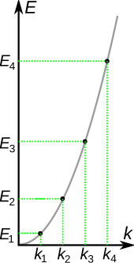
Here one must notice that now, since the particle is not entirely free but under the influence of a potential (the potential (V) described above), the energy of the particle [25 - 26] is not the same thing as it's kinetic energy (KE) [26] where (p) is the momentum of the particle, and thus the wave number (k) actually describes the energy states (O [n] ) of the particle, not the momentum states (p [n]) (i.e. it turns out that the momentum (p) of the particle is not given by kinetic energy (KE) [26] ). In this sense, it is quite dangerous to call the number (k) a wave number, since it is not related to momentum (p) like "wave number" (w) usually is. The rationale for calling (k) the wave number is that it enumerates the number of crests that the wave function (w) has inside the box, and in this sense it is a wave number. This discrepancy can be seen more clearly below, when we find out that the energy spectrum (E [n]) of the particle is discrete (only discrete values of energy are allowed) but the momentum spectrum (p [n]) is continuous (momentum can vary continuously) and in particular, the energy (E) momentum (p) relation [26] for the particle does not hold. As said above, the reason this relation between energy and momentum does not hold is that the particle is not free, but there is a potential (V) in the system, and the energy (E) of the particle is the sum of the kinetic energy (KE) and potential energy (V).
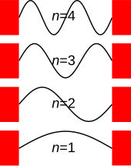
The amplitude (C) of the wave function at a given position is related to the probability of finding a particle there, [31]. The wave function (w) must therefore vanish everywhere beyond the edges of the box. Also, the amplitude (C) of the wave function (w) may not "jump" abruptly from one point to the next. These two conditions are only satisfied by wave functions (w) using the sine wave, [17], using the wave number (k [n] ), [17] and the energy (E) equation [28 - 30].
For a shifted box (xc = L/2).
The solution is particularly simple.
The simplest solution is when the wave number (k) or the constant coefficient (C) are zero. This yields a trivial wave function (w) that also equals zero, which describes a particle that does not exist anywhere in the system.
Negative values of (n) are neglected, since they give wave functions (w) identical to the positive (n) solutions except for a physically unimportant sign change.
Here one sees that only a discrete set of energy (E) values and wave numbers (k) are allowed for the particle.
Usually in quantum mechanics the wave function (w) and the first derivative of the wave function ([d/dx] w) be continuous. This requirement would lead to the only solution being the constant zero function. This not what we desire, so we give up this demand (as this system with infinite potential (V) can be regarded as a nonphysical abstract limiting case, we can treat it as such and "bend the rules").
Note that giving up this requirement means that the wave function (w) is not a differentiable function at the boundary of the box, and thus it can be said that the wave function (w) does not solve the Schrödinger equation at the boundary points (-a, or a), [1 - 3] but does solve it everywhere else.
Finally, the unknown constant (C) may be found by normalizing [] the wave function (w) so that the total probability density of finding the particle in the system is 1, [31 - 36]. Remember, the particle must be somewhere.
The constant coefficient (C) is the square root of (L / 2), [32].
Thus, (C) may be any complex number with absolute value; these different values of (C) yield the same physical state, so (A) can be selected to simplify.
It is expected that the eigenvalues, i.e., the energy of the box should be the same regardless of its position in space, but changes. Notice that represents a phase shift in the wave function. This phase shift has no effect when solving the Schrödinger equation, and therefore does not affect the eigenvalue.
If we set the origin of coordinates to the center of the box, we can rewrite the spatial part of the wave function using the sie and cosine function, [33 - 35], to take into account the even and odd values of (n).

Momentum wave function
The momentum wave function w (p, t) is proportional to the Fourier transform of the position wave function (w). With (note that the parameter (k) describing the momentum wave function (w) below is not exactly the special k[n] above, linked to the energy [36 - 37]
sinc is the cardinal sine sinc function,
sinc(x) = sin(x)/x.
For the centered box (xc = 0), the solution is real and particularly simple, since the phase factor on the right reduces to unity. (With care, it can be written as an even function of p.)
It can be seen that the momentum spectrum in this wave packet is continuous, and one may conclude that for the energy state described by the wave number (k [n]), the momentum (p) can, when measured, also attain other values beyond the initial momentum (p), [38].
Hence, the energy E [n] is for the nth eigen state O [n], does not strictly hold for the measured momentum (p) for kinetic energy (KE); the energy eigen state O [n] is not a momentum eigen state, and, in fact, not even a superposition of two momentum eigen states, as one might be tempted to imagine. Peculiarly, it has no well-defined momentum (p) before measurement!

Position and momentum probability distributions
In classic physics, the particle can be detected anywhere in the box with equal probability. In quantum mechanics, however, the probability density (P) for finding a particle at a given position (x) is derived from the wave function (w). For the particle in a box, the probability density (P) for finding the particle at a given position (x) depends upon its state O [n], and is given by a probability density function (P [n] (x, t) ), [44 - 47].
For any value of (n) greater than one, there are regions within the box for which (P (x) = 0), indicating that spatial nodes exist at which the particle cannot be found.
In quantum mechanics, the average, or expectation value of the position <x> of a particle is the integral of positin (x) times the probability density function (P [n]), [48 - 53].
For the steady state particle in a box, it can be shown that the average position <x> is always at the center (xc), regardless of the state of the particle. For a superposition of states, the expectation value of the position will change based on the cross term, which is proportional to cos (w t), [].
The variance in the position is a measure of the uncertainty in position (Δx) of the particle, [54 - 55].
The probability density for finding a particle with a given momentum (p) is derived from the state function (O [n] ). As with position (x), the probability density (P) for finding the particle at a given momentum (P [n] (p, t) ) depends upon its state O [n], and is given by the equation in [56]. The expectation value for the momentum <p> is then calculated to be zero, and the variance in the momentum (Δp) is calculated to be (h-bar PI n / L)^2, [57].
The uncertainties in position (Δx) and momentum (Δp) are defined as being equal to the square root of their respective variances, [58].
This product increases with increasing (n), having a minimum for (n = 1). The value of this product for (n = 1) is about equal to (0.568 h-bar), which obeys the Heisenberg uncertainty principle, which states that the product will be greater than or equal to (1/2 h-bar), [59].

Energy levels
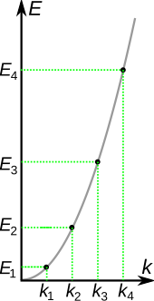
The energies that correspond with each of the permitted wave numbers may be written as The energy levels increase with , meaning that high energy levels are separated from each other by a greater amount than low energy levels are. The lowest possible energy for the particle (its zero-point energy) is found in state 1, which is given by The particle, therefore, always has a positive energy. This contrasts with classical systems, where the particle can have zero energy by resting motionlessly. This can be explained in terms of the uncertainty principle, which states that the product of the uncertainties in the position and momentum of a particle is limited by It can be shown that the uncertainty in the position of the particle is proportional to the width of the box. Thus, the uncertainty in momentum is roughly inversely proportional to the width of the box. The kinetic energy of a particle is given by , and hence the minimum kinetic energy of the particle in a box is inversely proportional to the mass and the square of the well width, in qualitative agreement with the calculation above.

Potentials in 1D

Potentials in 2D

Potentials in 3D

Linear Potential

Rectangular Potentials

Indefinite Square Wells

Central Potential

Bound States

-V1
0
-a
x
V0
a
A bound state is a composite of two or more fundamental building blocks, such as particles, atoms, or bodies, that behaves as a single object and in which energy is required to split them.
A proton and an electron can move separately; when they do, the total center-of-mass energy is positive, and such a pair of particles can be described as an ionized atom. Once the electron starts to "orbit" the proton, the energy becomes negative, and a bound state – namely the hydrogen atom – is formed. Only the lowest-energy bound state, the ground state, is stable. Other excited states are unstable and will decay into stable (but not other unstable) bound states with less energy by emitting a photon.
A positronium "atom" is an unstable bound state of an electron and a positron. It decays into photons.
Any state in the quantum harmonic oscillator is bound, but has positive energy. Note that as the limit of (x) approaches infinity the potential (V) of a quantum harmonic oscillator equals infinity, the discussion concerning the nucleus, proton and Hubbard and Jaynes model don't apply.
A nucleus is a bound state of protons and neutrons (nucleons).
The proton itself is a bound state of three quarks (two up and one down; one red, one green and one blue). However, unlike the case of the hydrogen atom, the individual quarks can never be isolated. See confinement.
The Hubbard and Jaynes–Cummings–Hubbard (JCH) models support similar bound states. In the Hubbard model, two repulsive bosonic atoms can form a bound pair in an optical lattice. The JCH Hamiltonian also supports two-polariton bound states when the photon-atom interaction is sufficiently strong.
Solutions to the Schrödinger equation must be continuous, and continuously differentiable. These requirements are boundary conditions on the differential equations, that is, the matching conditions between the solutions inside and outside the well.
Note that the finite potential well is symmetrical, so symmetry can be exploited.
As (x) goes to negative infinity, the term (A) goes to infinity. Likewise, as (x) goes to positive infinity , the term (G) goes to infinity. In order for the wave function to be square integrable, we must set both (A) and (G) to zero.
The overall wave function (w) must be continuous and differentiable and the borders of each region. In other words, the values of the functions w (x) and their derivatives w' (x) or [d/dx] w(x) must match up at the boundary points, (-a and a).
These equations have two sorts of solutions:
- symmetric, for which C = 0 and B = F , and
- anti-symmetric, for which D = 0 and B = − F .
For the symmetric case we get ..
For the anti-symmetric case we get ..
Recall that both (a) and (p) depend on energy (E). What we have found is that the continuity conditions cannot be satisfied for an arbitrary value of the energy (E); because that is a result of the infinite potential well case. Thus, only certain energy (E) values, which are solutions to one or either of these two equations, are allowed. Hence we find that the energy levels E [n] of the system below the potential (V0) are discrete; the corresponding eigen functions O (x) are bound states. By contrast, for the energy levels E [n] above the potential (V0) are continuous.
The energy equations cannot be solved analytically.
In the symmetric case, there always exists at least one bound state, even if the well is very shallow.
Solutions to the energy equations are aided by rewriting them with the dimensionless variables (u and v), and note from the definitions of (a and p), the master equations, [].
By plotting (v tan v) vs (-v cotan v) solutions can be found where the curves intersect. Each curve represents a possible solution, within the range . The total number of solutions (N) is therefore determined by dividing the radius of the circle (u0), by the range of each solution (PI / 2) and using the floor or ceiling functions.
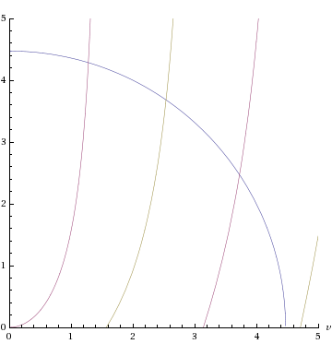
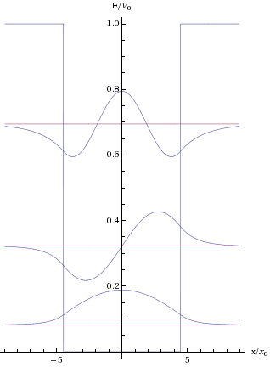
If we want, we can go back and find the values of the constants (C, D, B, F) in the equations now (we also need to impose the normalisation condition). Shown above, are the energy levels E [n] and wave functions (w), [].
We note that however small (u0) is (however shallow or narrow the well), there is always at least one bound state.
Two special cases are worth noting. As the height of the potential (V) approaches infinity, the radius of the semicircle gets larger and the roots get closer and closer to the values (n PI / 2), and we recover the case of the infinite square well.
The other case is that of a very narrow, deep well - specifically the case when the potential (V) approaches infinity and the well width approaches zero with (Vo L) fixed. As ( u = sqr (Vo L) ) it will tend to zero, and so there will only be one bound state. The approximate solution is then (v^2 = uo^2 - uo^4) [], and the energy (E) tends to ( -m L^2 Vo^2 / 2 h-bar^2 ). But this is just the energy of the bound state of a Delta function potential of strength (Vo L), as it should be.
A simpler graphical solution for the energy levels can be obtained by normalizing the potential (V) and the energy (E) through multiplication by (8 m L^2 / h-bar^2).
The normalized quantities are
Vo2 = Vo (8 m L^2 / h-bar^2 )
E2 = E (8 m L^2 / h-bar^2 )
giving directly the relation between the allowed couples (Vo, E) as
sqr (Vo2) = sqr (E2 | sec ( sqr (E2 PI / 2) ) |
sqr (Vo2) = sqr (E2 | csc ( sqr (E2 PI / 2) ) |
for the even and odd parity wave functions (w), respectively. In the previous equations only the positive derivative parts of the functions have to be considered. The chart giving directly the allowed couples is reported in the figure.

UnBound States
If we solve the time-independent Schrödinger equation for an energy (E > Vo), the solutions will be oscillatory both inside and outside the well. Thus, the solution is never square integrable; that is, it is always a non-normalizable state. This does not mean, however, that it is impossible for a quantum particle to have energy greater than (Vo), it merely means that the system has continuous spectrum above (Vo). The non-normalizable eigenstates are close enough to being square integrable that they still contribute to the spectrum of the Hamiltonian as an unbounded operator.

Asymmetric well
Consider a one-dimensional asymmetric potential well given by the potential well V (x), [], where V 2 > V 1 .
The corresponding solution for the wave function with (E < V 1) is found to be w ( x ).
The energy levels E [n] are determined once (p) is solved as a root of the following transcendental equation, [], where (n) is a positive integer from one through infinity, []. Existence of root to the equation [] is not always guaranteed, for example, one can always find a value of (a) so small, that for given values of (V1 and V2), there exists no discrete energy level. The results of symmetrical well is obtained from above equation by setting V1 = V2 = Vo.

Scattering States

Tunneling

Double Well

Square Barrier

Finite Square Well Potential
The finite potential well (also known as the finite square well) is a concept from quantum mechanics. It is an extension of the infinite potential well, in which a particle is confined to a "box", but one which has finite potential "walls". Unlike the infinite potential well, there is a probability associated with the particle being found outside the box. The quantum mechanical interpretation is unlike the classical interpretation, where if the total energy of the particle is less than the potential energy barrier of the walls it cannot be found outside the box. In the quantum interpretation, there is a non-zero probability of the particle being outside the box even when the energy of the particle is less than the potential energy barrier of the walls (cf quantum tunnelling).

Infinite Square Well Potential

Simple Harmonic Oscillator Potential

Binding Potentials

Non Binding Potentials

Forbidden domains

Forbidden regions

Quantum corral

Classically Allowed Regions

Classically Forbidden Regions

Regions

